**Pulse Width Modulation (PWM)**

1. First you need to make your configuration using the .ioc:

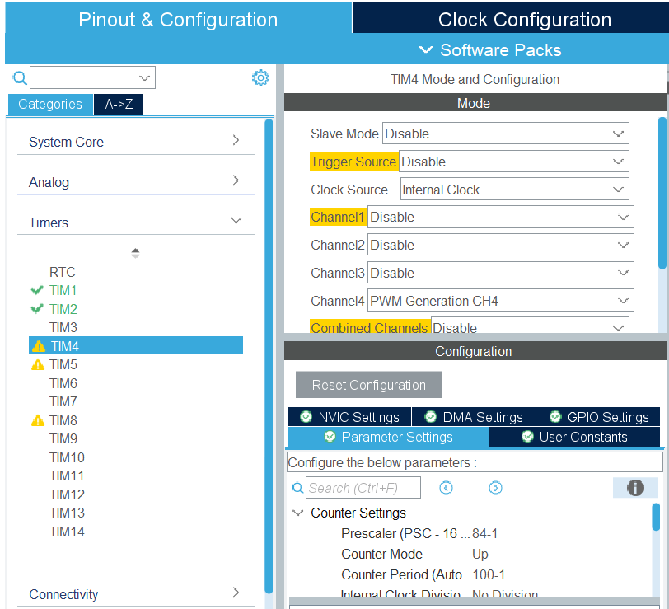Select Tim4

Clock Source: Internal Clock

Channel4: PWM generation CH4

Prescaler: 84 – 1

Counter Period: 100 - 1

1. Make sure you configure the System Core -> SYS

Debug to Serial Wire and Timebase Source to SysTick

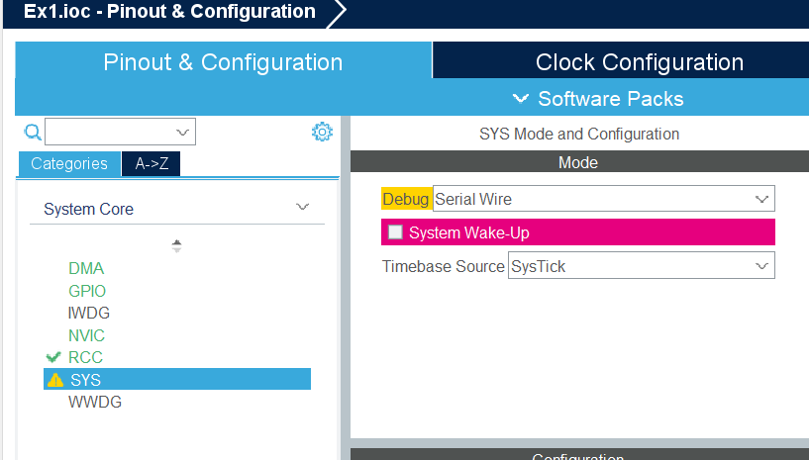

1. Also select one of the LED’s pin as your PWM pin signal:

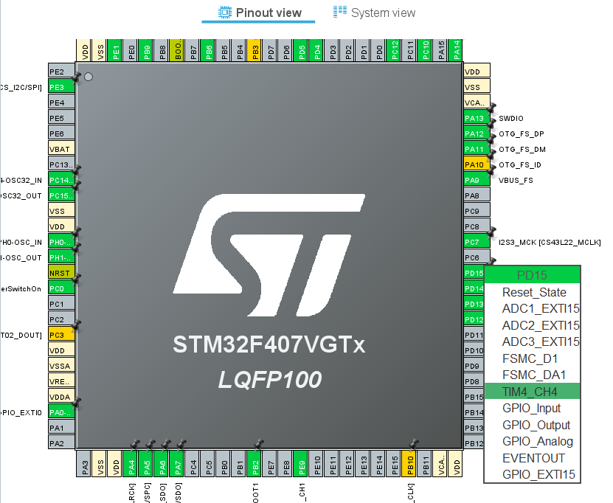

1. This 3 formulas will help you understand why we configure the timer that way :

For a more details about all the formulas and why we use them whatch: https://www.youtube.com/watch?v=OwlfFp8fPN0

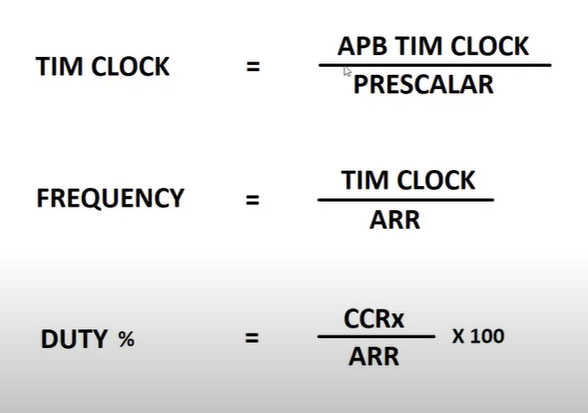

1. Now we are ready to generate our code:
2. Make sure you made the right configuration:

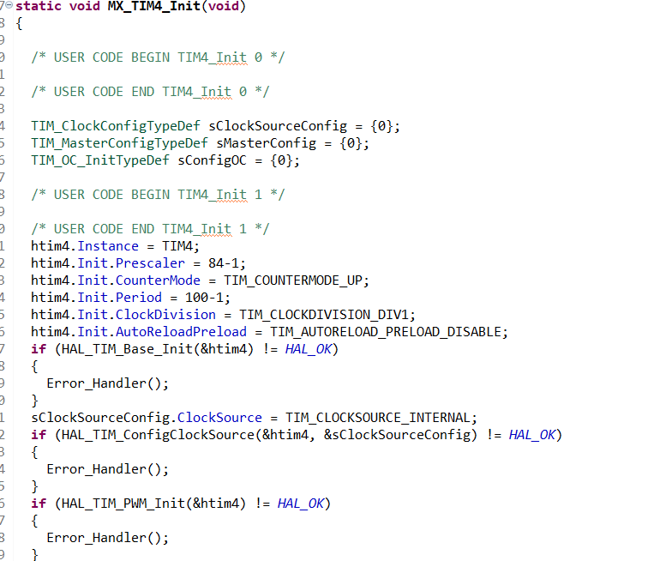

1. Inside the int main() write that code :

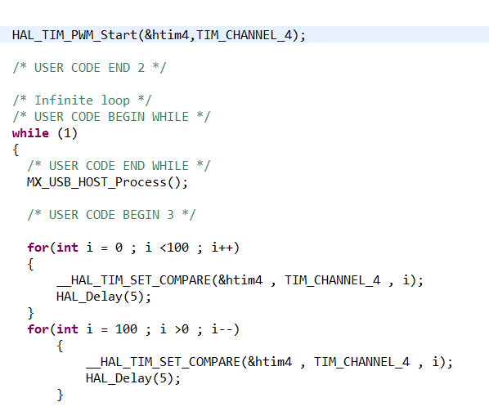

1. Now we are ready to build the project an run it to be able to see our led change the intensity of the light from 0% to 100% to 0% and so on , making 1% steps .